TOURISM AWARD MARCO POLO
to accommodation facilities
with services focusing on the Chinese market

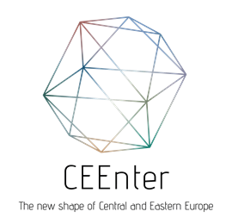

APPLICATION FORM - Hotels - 2022

Please use this form to apply for the Tourism Award Marco Polo 2022.
Application Deadline: 30th June 2022
Send to e-mail tcc@mfa.gov.hu

Applicant:
Address:
Website:
Website in Chinese (if applicable):
Contact data
Name:
E-mail:
Phone:
Give your company profile in max. 150 words (Refer to your results in the Chinese market before COVID-19 pandemic and how you changed your focus as a consequence of the crisis.)

Description of your China specific services that were newly introduced during the pandemic (max 1200 words):
List all newly introduced COVID measures that create a safe environment for your guests and explain how that meets the highest expectations of Chinese guests. Describe how you went above and beyond the regular (mandatory) preventive and health measures at your property:

Please support your application with supplementary documents (marketing materials, media releases, links, photos, videos, customer reviews, etc.):

Any other relevant information (optional):
Date, place, signature of the Applicant:

