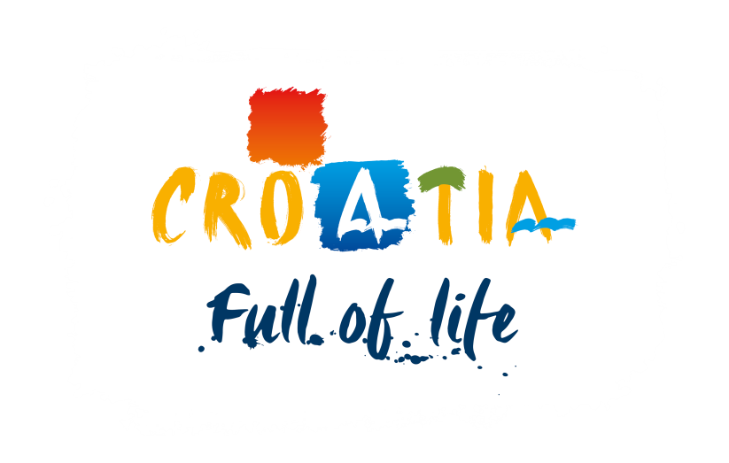

Selection of a Media Agency for the Design of an Advertising Strategy, Media Plan, and the Implementation of Marketing Activities of the CNTB on international markets - 2019

Author:
Croatian National Tourist Board
Zagreb, December 2018

TABLE OF CONTENTS

INTRODUCTION

Preamble
  - 2020 Vision and Marketing Goals
  - Target Consumers
  - Key Tourism Products
  - Targeted Geo-Zones

- TERMS OF REFERENCE

- SELECTION OF TENDERERS

- INTRODUCTION

  - Preamble

The Marketing Plan for the 2014-2020 period is defined by three goals

In order to help achieve the set objectives of the National Strategic Tourism Plan by 2020, the CNTB Governing Body “Sabor” has approved the Strategic Marketing Plan for Croatian Tourism (SMPHT) for the 2014-2020 period, which serves as the basis for the design of the advertising strategy and the implementation of marketing activities.

The Plan includes three main goals:

substantial strengthening of the brand Croatia as a tourist destination
    - attracting additional number of tourists in the pre and post seasons
    - increase in the average daily expenditure of tourist arrivals

External services to be procured by the CNTB

For the purpose of a successful implementation of the Strategic Marketing Plan, the CNTB shall collect and select (by way of a public tender) bids of specialized agencies to carry out the following services:

- design of the Advertising Strategy and the Media Plans, implementation of activities confirmed in the media plan for 2019.

Aim and Content of this Documentation

The content of this documentation has been created to help understand the context and characteristics of the requested service, and contains:

Section 1:

- Introduction – Main objectives and strategy of the Marketing Plan

Section 2:

- Terms of Reference – Defining the subject of the tender and evaluating the service value

Section 3:

- Bid Selection – Collecting, evaluating and selecting the bid

Annexes:
- Submission Forms: 1 – 7

Note: Dates and times in this documentation shall be calculated according to the official time as valid in the Republic of Croatia.

Clarifications and interpretation of the documentation

In case of any questions/doubts or need for clarification, please contact us at the e-mail address media.tender@htz.hr, not later than:

- For the qualification phase: January 14th 2019 by 12:00 CET
- For the tendering phase: February 18th 2019 by 12:00 CET

2020 Vision and Marketing Goals
Croatia, as a tourist destination, has great opportunities deriving from its natural and cultural attractions, pristine nature, unique lifestyle, remarkable network of islands, extensive experience in tourism business, tradition in hospitality, and a favourable geographical location in the European Union.

Vision

In the context of the proposed vision, Croatia wants to play an important role in all major areas of tourism: experience, discovery, entertainment, business.

The following figure describes the vision and its associated marketing objectives, which are later described in detail:

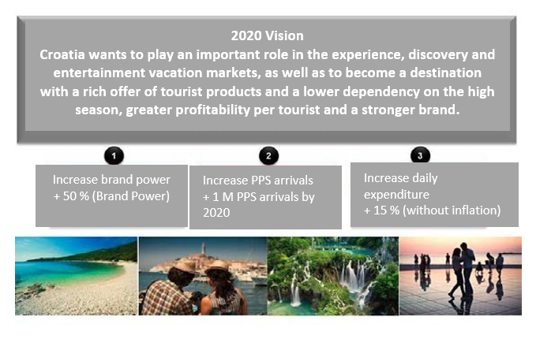
Vision and Marketing Goals from the 2014-2020 Plan

Marketing Goals

Croatia is facing some major challenges that are currently preventing the country from achieving the proposed vision: its tourist brand is not well known and understood on the market, tourist demand is predominately concentrated during the 80 days of summer, and the average expenditure per person per day is below the Mediterranean average.

The following table shows how the marketing plan should contribute to achieving the proposed tourism vision of Croatia.

Three Goals

Problems to be solved | Main goal | Auxiliary goals per segment
a. Croatia's brand recognition is weak. | To increase brand power  + 50 % (Brand Power) | Guests  75% of brand awareness among the target population;  Understanding Croatia's offer  among 60% of the target population.
b. Croatia has difficulty in attracting tourists in pre and post season (PPS)  (with the tendency of year-over-year growth) | To increase PPS arrivals | Guests  influence 50 million potential PPS arrivals
c. The average daily expenditure per  guest is low. | To increase the average  expenditure per guest  + 15% (without inflation) | Guests  Increase the average expenditure per guest (+ 15% net) by 2020

  - Target Consumers

Target consumers by demographic variables

Friends | Couples | Families
Age: 18-29 Household income: medium and high  Urban residents | Age: 30-39 / 40-54 / 55+  Household income: medium and high Urban residents | Age: 30-39 / 40-54  Household income: medium and high Urban residents Travelling with or without children
(Detailed information will be available exclusively to Tenderers in the second phase, through a brief).

Key Tourism Products

Key tourism products (based on the portfolio of tourism products defined by the Strategy of Tourism Development in Croatia by 2020) represent one of the starting points for the design of a marketing and communication strategy of the CNTB during 2019:

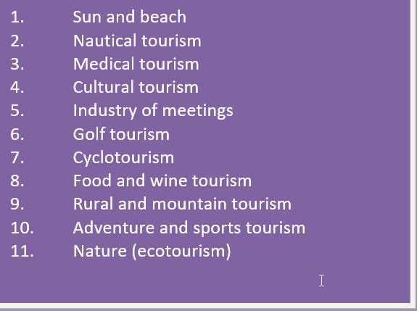

Targeted Geo-Zones

In the design of a marketing and communication strategy in key outbound tourism markets, the CNTB shall, in the period until 2020, follow the guidelines of the SMPHT (based on the market portfolio defined by the Strategy of Tourism Development in Croatia by 2020):

As marketing resources are limited, it is crucial to target specific geo-zones (not entire countries) based on market attractiveness and their connections to Croatia. According to the criteria of market potential and the availability of non-stop/direct flights, or flights with one connection, that is, destinations that are in the area of 4 to 6 hours away by car from Croatia, the CNTB shall deliver the targeted geo-zones exclusively to tenderers in the second phase of the procedure.

TERMS OF REFERENCE

Subject of the Tender
  - Deliverables Provided by the Selected Tenderer
  - Estimated Value of Service

In order to achieve the three objectives of the 2014-2020 marketing plan (substantial strengthening of the brand Croatia as a tourist destination, attracting additional number of tourists in the pre and post seasons, and increasing the average daily expenditure of tourist arrivals), the CNTB will perform significant efforts in an overall communication linked to the achievement of selected goals in the area of targeted geo-zones. Measures shall include different integrated marketing tactics in offline and online segments, and a coordinated approach to markets and target groups through cooperation between the selected marketing agency, PR agency and CNTB representative and branch offices abroad, all for the purpose of achieving goals defined by the Strategic Marketing Plan for Croatian Tourism.

Subject of the Tender

The subject of the tender includes the following services and activities:

Design of an advertising strategy
- Design of media plans
- Implementation of the CNTB activities confirmed in the media plan for 2019 (media buy).

The plan designed by the selected Tenderer shall have as its goal the precise targeting of target groups in specific geo-zones according to the expressed interests linked to their trip to Croatia, with the objective of reaching the three main goals in the following markets:

- Germany
- UK
- Austria
- Poland
- France
- Sweden
- The Netherlands
- Belgium
- Italy
- Switzerland
- Russia
- Hungary
- Norway
- Ukraine
- The Czech Republic

Tenderers shall submit a bid for at least 5 markets covered by this tender.

A contract on performing services that are the subject of this tender shall be concluded with one or more agencies, depending on the results.

Deliverables Provided by the Selected Tenderer

The service provided by the selected Tenderer includes the following:

Market analysis and research

The selected Tenderer shall analyse and research each market. The analysis, based on which the media plan for each market shall be made, includes:

- analysis of individual target groups
- media analysis of the market
- analysis of the media consumption of individual target groups
- consumer journey – when and how does the consumer choose a destination for vacation
- analysis of the competition (marketing activities of other destinations on a certain market)

Advertising strategy

The selected Tenderer shall design the following on the basis of the carried-out analysis and given budgets:

- Brand and PPS (pre and post season) advertising strategy on the market (proposal for a marketing channel and medium, proposal of advertising periods for each campaign pursuant to the available budget, as well as explanation thereof)
- Proposal for media partners on the market – with an explained manner of cooperation and analysis of effects
- Advertising strategies shall be made for all markets using the same form

Media plans and setting up KPIs

The CNTB intends to implement 4 campaigns in 2019. The CNTB shall deliver a list of all envisaged campaigns, their goals and a detailed brief of 2019 campaigns to the tenderers that will be invited to the second phase of the tender, along with templates for the media plan and media specifications.

- Media plans have to include:
  - A detailed 2019 media plan with prices and specifications for advertising design for all campaigns pursuant to the brief
  - Key performance indicators per channels:
Print: circulation, advertising position, target group reach TV/RADIO: GRP, TRP, impressions, target group reach Outdoor: location quality, format quality, impressions
Online: impressions/clicks, content interaction

- The media plan does not have to include advertising activities on search engines and social media and programmatic media buying
- Media plans per segments have to be made using the same form to be provided to the tenderer by the CNTB in the second phase

Implementation of advertising (media buy)

The Croatian National Tourist Board shall, on the basis of the submitted documentation and in accordance with the conditions set up by this documentation, as well as possible additional criteria that shall be delivered to tenderers together with the instructions for participation in the second phase of the tender, select the best bid and sign a contract for 2019 with the selected tenderer. According to the accepted bid, the Tenderer shall implement advertising campaigns for the CNTB, which includes:

- finishing and optimising the accepted media plan per segments according to the brief and its harmonisation with the CNTB HQ and CNTB representative offices on each outbound tourism market
- final definition of KPIs of single campaigns per single markets
- media buying and final execution of the media plan
- placing the campaign
- ensuring that the CNTB has unlimited access to systems and platforms for monitoring and optimisation of campaigns

Monitoring and optimisation in accordance with set KPIs

By setting up planned campaigns, the successful Tenderer is obliged to carry out:

- regular monitoring of campaigns
- monitoring of the execution of key performance indicators (KPIs) of campaigns
- optimisation of campaigns in order to achieve KPIs

Regular monthly campaign reporting

The selected tenderer will report regularly on the implementation of the campaign and the fulfilment of the set performance indicators (KPIs) of the campaign, as well as present evidence of all activities planned and carried out in accordance with the requirements of the CNTB:
- monthly reporting on campaign implementation
- at the client's request, send a report in any of the campaign phases within the set deadline
- making accounts of the implemented activities and bills of quantities according to the specifications of the CNTB, upon closure of each campaign for each outbound market (failure to act pursuant to the above shall be penalised)

Report on implemented campaign, post-buy analysis and suggestions for improvement in future campaigns
In addition to the evidence of campaign implementation, the tenderer will also make as follows:

- draft a final report (post-buy analysis) about the implemented campaign according to the concept to be delivered by the CTNB
- make suggestions for improving future campaigns
- create a system for learning and knowledge-exchange between the agency and the CNTB

Other provisions

- The agency has to introduce its team in charge of the client (CNTB).
- The agency has to react promptly to the client's every request.
- Media plans, analyses and reports shall be done on the same form for all markets (to be delivered by the CNTB)
- State which Ad Serving system shall be used for digital campaigns of the CNTB
- The agency fee shall be calculated only and exclusively to the price of media buying
- All additional costs (ad serving costs, set up costs...) shall be expressed separately, but the total amount shall not exceed the budget as stipulated in the brief.

Total budget for advertising (includes the agency fee and all other agency costs relating to media buying)

For the activities related to the implementation of online and offline marketing activities in 2019 the CNTB foresees the budget in the total amount of HRK 33,630,000.00 (exclusive of VAT). Such amount must include the agency fee and all agency costs.

The CNTB reserves the right for the duration of the contract to modify the amount of the budget in any part, with prior consent of the CNTB Tourism Council.

Note:

The agency fee is calculated exclusively to the price of media buying, and it includes the cost of the implementation of the contracted services and unlimited rights to use all submitted strategies, research and analyses, and all other costs incurred by performing services that are the subject of this tender.

3. SELECTION OF TENDERERS

Qualification Phase
  - Delivery of Bids
  - Assessment and Selection of Bids

The tender shall have three phases:

Qualification phase, tendering phase and bid assessment phase.

  - Qualification Phase

The qualification phase includes publication of the call for interest and selection of tenderers that will be invited to deliver their bids in the following phase of the tender, provided that they qualify for the second phase.

The call for interest is public and aimed at all interested subjects that qualify for the following phase of the procedure.

The call for interest shall be published on the following website: www.htz.hr

Eligibility:

- Experience

The agency must have at least 5 years of adequate experience in performing activities that are the subject of this tender for clients in the tourist sector in the domestic and international market.

The agency shall submit the following evidence:
  - list of reference clients in the tourist sector (at least 3) and communication campaigns implemented in the last 5 years
  - excerpt from the companies register or other business register, that is, extract from the register of competent tax authorities, with the indicated date of establishment, not older than 3 months

Paid tax duties

A signed Statement for each agency separately of paid tax duties that is attached to this Call.

Instead of a signed statement, agencies with headquarters in Croatia shall deliver a certificate of the competent tax authority on paid tax duties in the Republic of Croatia, not older than 30 days from the date of the bid delivery.

Statement of good conduct
A signed Statement of Good Conduct for each agency separately that is attached to this Call.

Consortium bidding

Consortium bidding is allowed.

A member of the consortium that is in charge of a single market must independently fulfil all prescribed conditions for that market and submit the requested documents as proof thereof. In addition to such members, the consortium may have other members that are not in charge for a single market but, in case of selection, will act as a leading agency that acts in their name and for their account towards the client.

Members of the consortium shall establish in advance and define jointly such leading agency that shall act in their name and for their account towards the client.

As evidence of the selection of a leading agency, members of the consortium shall deliver signed statements of single members of the consortium (Form 6), where it is clearly stated who among the members is selected as the leading agency in the tendering procedure, acting in the name and for the account of members, as well as the fact that, in case of selection of that consortium for any of the markets for which the consortium sent the bid, the leading agency shall bear all rights and obligations from the contract towards the client, without any single rights of members directly towards the client.

In case of a consortium, the following documentation shall be delivered for each group member in charge of a single market:
- Evidence of experience on that market
  - List of reference clients in the tourist sector (at least 3) and communication campaigns implemented in the last 5 years
  - Excerpt from the companies register or other business register, with indicated date of establishment, that is, excerpt from the register of competent tax authorities
- Evidence of paid tax duties
  - Statement of paid taxes (Form 4), or
  - for agencies with headquarters in the Republic of Croatia – certificate of the competent tax authority (Statement of the consortium)

In case of a consortium, the following documentation shall be delivered for the leading agency:

- Evidence of paid tax duties
  - Statement of paid taxes (Form 4), or
  - for agencies with headquarters in the Republic of Croatia – certificate of the competent tax authority (Statement of the consortium)
- Statement of the consortium – the leading agency confirms with its signature every single statement of members of the consortium
- Form – General information about the Tenderer responsible for the project
- Form – Composition of the work-team and tasks.

If the leading agency also acts as one of the members of the consortium, who is in charge of a certain market, it shall also prove its experience in the market in question.

Important note:
The CNTB may subsequently check the authenticity of data, recommendations, proofs and eligibility certificates.

If a certain piece of evidence is not clear or is missing, the CNTB may call the tenderer to explain or deliver it within the deadline set up for that purpose.
The bid price does not have to be submitted in this phase.

Tenderers not meeting the stipulated requirements or documentation shall not be considered. If a tenderer is bidding for more markets, but does not meet the stipulated criteria for a certain market, its bid shall not be considered only with respect to that market.

Selection:
The Technical Committee shall review all the documentation submitted in the qualification phase and decide which of the tenderers meet the stipulated requirements, and those tenderers shall be invited to the second phase of the procedure.

The Technical Committee shall decide on the qualification of the tenderer for the following phase by taking into consideration the above-mentioned criteria and delivered documentation.

After the CNTB sends the call for participation in the next phase, it shall deliver to selected tenderers documentation that is necessary for the bid, detailed instructions and conditions for further participation in the procedure, as well as the terms of the contract that shall be signed with the selected tenderer.

Delivery deadline for the necessary documentation is January 18th 2019 by 16:00 CET. Documentation shall be delivered to the following email address: media.tender@htz.hr

The CNTB may request from tenderers that have delivered the documentation in due time to supplement the documentation, or provide additional explanations or evidence necessary for proving their qualification. Should that be the case, the CNTB shall determine independently the additional delivery deadline.

  - Tendering Phase

    - Delivery of Bids

The tenderer that has been invited to the tendering phase shall confirm its participation in the tender not later than on January 28th 2019 by 16:00 CET, in writing to the email address media.tender@htz.hr and deliver its final bid not later than February 25th 2019 by 16:00 CET.

If the requested confirmation is not received within the indicated deadline, the CNTB shall consider that the Tenderer is withdrawing from participation in the tender.

Content of proposals/bids

Together with a compulsory filled-in and signed Tender Submission File that is attached to this document, the bid shall contain:

Information about the tenderer and members of the work-team
- Market analysis and research
- Advertising strategy per market

- Media plans and defined KPIs:
- final media plans for all campaigns stated in the brief, together with the defined KPIs
- specifications of adverts proposed in media plans

Agency fee for all markets
- Detailed description of campaign implementation and campaign monitoring (especially digital campaigns) as well as a list of tools that will be used
- Specifications about the Ad Serving system that shall be used
- Reports and training

    - Delivery of Bids

All documentation shall be delivered exclusively by post to the address of the CNTB HQ (Croatian National Tourist Board, Iblerov trg 10/IV, p.p. 251 10000 Zagreb) with the following indication: “Natječaj za medijsku agenciju”) (“Tender for a Media Agency”), in a sealed envelope containing a hard copy of the bid, as well as a soft copy on a digital medium (USB flash drive).
Deadline for the delivery of bids is February 25th by 16:00 CET.

  - Assessment and Selection of Bids

The Committee’s evaluation
The Selection Committee shall review the delivered bids. The Committee shall evaluate each media plan per segment, and its evaluation shall represent 100% of the total grade for a given market. The tenderer whose bid (media plan) achieved the highest score for a certain market shall be selected.
If two or more agencies achieve the same score for one or several markets, the bid which was sent first shall be selected (taking into consideration the date of receiving the bid in the tenderer’s post office).
The CNTB shall have the right to choose only certain bids of a single tenderer, which the Selection Committee has graded as the best.

The assessment of bids is based on a discretional vote of each member of the Committee.

Grading categories and points

Category | Maximum score
1. Media plans | 40
2. Rationale & creativity of the market strategy | 30
3. Analysis of markets and target groups | 10
4. Agency fee | 10
5. Usage of original and innovative advertising formats and channels | 10
6. TOTAL (1+2+3+4+5) = | 100

Evaluation of agency fee

The score for the agency fee shall be ranked in a way that the bid with the lowest indicated agency fee shall obtain the maximum of 10 points, and all the following bids shall obtain 1 point less each until 0, after which all bids with a higher agency fee shall obtain 0 points each.

Example

Tenderer Fee Points
Agency A 0% - 1% 10 points
Agency B 1,1% - 2% 9 points
Agency C 2,1% - 3% 8 points
Agency D 3,1% - 4% 7 points
Agency E 4,1% - 5% 6 points
Agency F 5,1% - 6% 5 points
Agency G 6,1% - 7% 4 points
Agency H 7,1% - 8% 3 points
Agency I 8,1% - 9% 2 points
Agency J 9,1% - 10% 1 point
Agency K more than 10% 0 points

The CNTB may decide, with prior consent of the CNTB Tourism Council, not to select any bid and is authorized to withdraw from the acceptance of the bid at all stages, until the contract has been signed with the successful Tenderer, without any liability for the compensation of any damages which the Tenderer has or may incur as a result.

Tenderers whose bids were not selected have no right to appeal or receive compensation for any costs related to this procedure.

The CNTB may decide subsequently to extend the deadline for bid delivery or in any way modify the terms from this documentation, with prior consent of the CNTB Tourism Council.

In case of the selection/acceptance of a bid, the CNTB has the right to request from the successful Tenderer the submission of all evidence that it considers relevant to prove the Tenderer’s capability to fulfil the undertaken obligations, and provide a certain standard of quality. In case when the above-mentioned evidence, according to the discretionary assessment of the CNTB, points to the inability or difficulty in fulfilling the undertaken obligations, that is, calls into question its quality, the CNTB shall desist from accepting the bid i.e. concluding the contract with the selected Tenderer, whereby no Tenderer shall have the right to the compensation of damages which have incurred, or which may incur, therefrom.

The CNTB reserves the right to further negotiate on the fee amount or on the decrease in prices for the proposed media plan with one or more tenderers per individual markets, whereby such tenderers shall be among the three most successful tenderers for a given market.

The obligations of the successful Tenderer after the selection

The tenderer is obliged to conclude a Service Provision Contract. The basic content of the contract shall be delivered to the tenderers which have qualified for the tendering phase together with the documentation and explanations regarding the drafting of the bid.

Agencies with which the contract is to be concluded shall, pursuant to the requirements from the contract, also deliver first call bank guarantees, which shall serve as appropriate guarantees for the due meeting of their liabilities.

Summary

First phase: Qualification procedure

- The deadline for the delivery of possible questions/doubts regarding the tender:

January 14th by 12:00 CET at media.tender@htz.hr

The deadline for the delivery of bids (filled-in submission forms): January 18th 2019 by 16:00 CET

The CNTB shall inform all Tenderers that participated in the qualification phase about the results of this phase by January 25th 2019. The Tenderers shall confirm the receipt of the notice and participation in the second phase by January 28th 2019.

Second phase: Tendering procedure

- The CNTB shall deliver by January 29th 2019 a brief and all other documentation necessary to deliver the bids.

- The deadline for the delivery of possible questions/doubts regarding the tender: February 18th 2019 until 12:00 CET, with the possibility of organising meetings, if necessary.

- Tenderers shall deliver their final bids to the address of the CNTB HQ with the following indication: “Natječaj za medijsku agenciju” (“Tender for a Media Agency”), in a sealed envelope containing a hard copy of the bid, as well as a soft copy on a digital medium (USB flash drive), not later than February 25th 2019 by 16:00 CET, after which the CNTB shall inform them about the schedule of presentations in Zagreb (framework dates: March 4th – March 11th 2019).

Submission Form 1 – General information about the Tenderer responsible for the project

Name of the legal entity
Registered office of the legal entity
E-mail of the legal entity
Tax number of the legal entity
Years of operation (registration date and name of the register)
Authorised representative of the legal entity (name, surname and function)

Signature of the authorised representative of the Tenderer Stamp of the Tenderer

Place

Date

Submission Form 2 – List of significant clients in the last five (5) years

Contract number | Name and address of the commissioner | Subject of the contract | Time and place of the completed contract
1
2
3
4
5
6
7
8
9
10
11
12
13
14
15

Signature of the authorised representative of the Tenderer Stamp of the Tenderer

Place

Date

Submission Form 3– Composition of the work-team and tasks

Full names of team members | Position in the work team | Tasks in the work team

Signature of the authorised representative of the Tenderer Stamp of the Tenderer

Place

Date

Submission Form 4– Statement of Paid Taxes

STATEMENT OF PAID TAXES

I, (full name) from ,
as a person authorised to represent the Tenderer
(company) with its registered office in , hereby declare that in the moment of giving this statement the Tenderer has no due and unpaid debts for taxes or social contributions in the Republic of Croatia, as well as in the country of its registered office.

In , on . (place) (date)

Seal

(signature of the authorised representative of the Tenderer)

Submission Form 5 Statement of Good Conduct

STATEMENT OF GOOD CONDUCT

by which I, (full name) from
declare that I have not been convicted by final judgement for any of the following criminal acts or corresponding criminal acts under the regulations of the country in which the Tenderer is seated or of the country which a person authorised under the law to represent the economic operator is a citizen of:
fraud, fraudulent business activities, accepting a bribe in business activities, offering a bribe in business activities, malpractice in public procurement procedures, evasion of taxes or custom duties, subsidy fraud, money laundering, abuse of position and powers, illegal favouring, accepting a bribe, offering a bribe, influence peddling, influence peddling bribery, criminal association and committing a criminal act through criminal association under the Criminal Code, that is, for the following criminal acts: fraud, money laundering, fraudulent business activities, accepting a bribe in business activities, offering a bribe in business activities, association for committing criminal acts, abuse of position and powers, abuse of state power, illegal mediation, accepting a bribe and offering a bribe, or corresponding criminal acts according to laws of the country in which the Tenderer is seated, that is, country of origin of the authorised representative of the Tenderer.

I am making this statement personally, as an authorised representative of the Tenderer
(company) with its registered office in

and for the Tenderer itself.

In , on . (place) (date)

Seal

(signature of the authorised representative of the Tenderer)

Submission Form 6. – Statement of the Consortium

STATEMENT OF THE CONSORTIUM

I hereby agree that in the tendering procedure for I am participating as a member of the consortium that consists of the following members:
1.
2.
3.

I agree that in this tendering procedure, as well as in contracting and performing all rights and obligations towards the client (communication with the client, conclusion of contracts, annexes and all other necessary legal tasks and issuing guarantees) the following operator acts in my name and for my account:
(leading agency), that will conclude with the client a contract based on the delivered bid for one or more markets and assume all rights and obligations from that contract towards the client, without any single rights of the members of this consortium directly towards the client.

In , on . (place) (date)
Seal

(signature of the authorised representative of the Tenderer)

Statement of the leading agency

I hereby agree to participate in the name and for the account of the aforementioned member of the consortium entirely. I, as the leading agency of the consortium, further agree to conclude with the client a contract based on the delivered bid for one or more markets, as well as assume all rights and obligations from that contract towards the client, without any single rights of the members of this consortium directly towards the client.

In , on . (place) (date)

Seal

(signature of the authorised representative of the Tenderer)

Tender Submission File

Name of the legal entity
Registered office of the legal entity
E-mail of the legal entity
Tax number of the legal entity
Authorised representative of the legal entity (name, surname and function)

MARKET | AGENCY FEE
Germany
UK
Austria
Poland
France
Sweden
Denmark
The Netherlands
Belgium
Italy
Switzerland
Russia
Hungary
Ukraine
The Czech Republic

The tenderer is to write in the table the percentage (%) of the agency fee for each market it is bidding for. Agency fee shall cover both online and offline advertising.

- Should the Client accept the bid, by signing this Tender Submission File we undertake to conclude a contract with the content as prescribed in the call for interest.
- The submitted bid is valid for 60 days from the day of its submission to the Client.

Signature of the authorised representative of the Tenderer Stamp of the Tenderer

Name and Surname:

Place and Date:

